**Automatic Speed Control and Accident Avoidance System**

**Mrs. Revathi S N1,Spoorthi H S2, Spoorti S H 3, V Tanuja4, Keertana K B5**

## 1-Assistant Professor,2,3,4,5-Students

## ECE Dept, GM Institute of Technology, Davangere -577006.

## [revathisn@gmit.ac.in](mailto:revathisn@gmit.ac.in) [spoorti15sh@gmail.com](mailto:spoorti15sh@gmail.com)

***Abstract****-*The "Automatic Speed Control and Accident-Avoidance System" is an advanced automotive safety technology designed to enhance road safety and reduce the frequency of accidents. This system integrates cutting-edge sensors, artificial intelligence, and vehicle control mechanisms to actively monitor and control a vehicle's speed and trajectory to prevent collisions and improve overall driving safety. The core components of this system include sensors such as cameras, LiDAR, radar, and ultrasonic sensors, which constantly collect data about the vehicle's surroundings. These sensors provide real-time information about road conditions, the presence of other vehicles, pedestrians, and potential obstacles. This data is processed by a sophisticated AI algorithm, which makes rapid decisions regarding speed adjustments and steering control to avoid potential accidents. The system's primary objective is to maintain a safe following distance from other vehicles, avoid sudden braking, and take preventive actions in critical situations, such as lane departure or impending collisions. It also takes into consideration factors like weather conditions and road surface conditions when making these decisions. In the event of an imminent collision, the system can take actions such as applying the brakes, steering the vehicle away from the danger zone, and providing warnings to the driver.

1. **INTRODUCTION**

The prevalence of vehicle accidents has become increasingly acute, with many attributed to drivers' inability to stop in time or pedestrians facing challenges while crossing roads. Research reveals that a significant portion of fatalities, approximately 35%, result from accidents, with 98% of these being fatal road accidents. While various vehicle industries have introduced artificial intelligence systems to mitigate such incidents, their complexity and cost pose limitations, leaving many at risk. This research aims to address this issue by proposing a cost-effective intelligent system designed to prevent sudden accidents. The system incorporates automatic speed control and accident avoidance features, ensuring driver safety. Operating in two stages, the system activates an alerting mechanism when an obstacle enters a specified range and autonomously engages braking if the obstacle approaches dangerously close to the vehicle's front without driver response. This intervention occurs across varying speeds, catering to both urban and rural driving scenarios. The research methodology involves studying relevant literature, selecting necessary materials, designing the control circuit, developing the microcontroller program, and finally implementing the system by interfacing software and hardware components. Through this approach, an effective and affordable accident avoidance vehicle system can be realized, contributing to enhanced road safety for all.

In recent years, there has been a surge in interest surrounding the development of automatic speed control and accident avoidance systems for vehicles, thanks to advancements in sensor technology. These systems aim to bolster road safety and curb the frequency of accidents by leveraging an array of sensors to gather real-time data about a vehicle's surroundings. By automatically adjusting speed and trajectory, they seek to evade potential collisions. Globally, road accidents pose a significant threat, leading to substantial loss of life and property. Human error, including distracted driving and failure to adapt to changing road conditions, ranks among the primary causes. Through sensors, automatic speed control and accident avoidance systems offer a promising solution, providing an added layer of safety via continuous monitoring and control of a vehicle's movements. These systems typically integrate a mix of sensors like cameras, radar, lidar, ultrasonic sensors, and GPS to capture data on the vehicle's environment, encompassing other vehicles, pedestrians, obstacles, road conditions, and traffic signs. Real-time processing of this data by an onboard computer facilitates informed decisions regarding necessary speed and trajectory adjustments to steer clear of potential collisions. Such systems find applicability across various

vehicle types, including passenger cars, commercial trucks, buses, and even autonomous vehicles. The potential benefits of these systems are vast. They promise a reduction in road accidents, preservation of lives, mitigation of injuries, and minimization of property damage. Furthermore, by optimizing vehicle speed and trajectory in a coordinated manner, they hold the potential to alleviate traffic congestion and enhance overall traffic flow.

# LITERATURE REVIEW

Adnan M. Al-Smadi, Wasan Al-Ksasbeh, Mohammad Ababneh, Manar Al-Nsairat (IEEE, 2020). “Intelligent Automobile Collision Avoidance and Safety System” [1]. This paper proposes a design for detecting an imminent collision and works to prevent or reduce the strength of the imminent collision at the rear or front of the vehicle. The method presented here uses an ultrasonic sensor. Detects that the driver is approaching his vehicle and displays an alert to the driver. This system measures the distance between two vehicles moving in the same lane and in the same direction. If the trajectory of an object is directed at your vehicle and becomes dangerous, the system will deploy security measures to your vehicle.

Mahesh A. Rakhonde, ; Prof. Dr. S. A. Khoje; Prof. R. D.Komati (IEEE, 2018). “Vehicle Collision Detection and Avoidance with Pollution Monitoring System Using IoT” [2]. This study focuses on enhancing intelligent vehicle systems by introducing various components to bolster overall functionality. The primary objective centers on real-time accident detection and the swift minimization of response times for medical assistance. Tire pressure monitoring serves as a preventive measure against accidents, while accident detection is facilitated through MCU nodes. Additionally, pollution levels are monitored using the MQ7 sensor. The envisioned system not only aims to reduce vehicle accidents but also provides valuable insights into environmental pollution levels, contributing to a safer driving environment and heightened environmental awareness.

P. Ramya, R.K. Kavin, R. Rathish, M. Sathees Kumar, R. Karthi Kumar (IJESC, 2020). “ Accident Avoidance and Prevention System” [3]. The project aims to provide a technical solution for detecting and monitoring driver fatigue levels to prevent accidents. It also focuses on detecting drunk driving by implementing a system that locks the vehicle's ignition if alcohol is detected in the driver's system. Additionally, the system controls the vehicle's direction to avoid accidents when it exceeds a specified distance limit. In the event of an accident, the system utilizes a GSM module to transmit relevant information to authorities or vehicle owners. The project addresses the three main causes of road accidents: fatigue, overtaking, and drinking, which are often related to the driver's condition. Given the limitations of police officers in checking every vehicle for alcohol consumption, an effective screening system using alcohol detectors is deemed necessary. By integrating Raspberry Pi and ultrasonic sensors, the system detects forward movement and can effectively control the vehicle's speed or adjust its direction to prevent accidents, such as swerving into another lane.

Aditi Padayar, Dipali Jadhav, Priti Pashte, Shweta Lagade, Prof.

S. K. Srivastava (JETIR, FEB 2020). “Microcontroller -based Accident Prevention System Using IOT” [4]. The primary objective of this project is to develop a system capable of determining the alcohol content in a driver's breath and automatically shutting off the vehicle if the alcohol concentration exceeds a preset limit. The project utilizes microcontrollers from the 8051 family, specifically the 89552 model. To detect alcohol content in human breath, an MQ3 alcohol sensor is employed, which provides analog output data. However, since 8051 microcontrollers cannot directly analyze analog data, a digital converter (analog-to-digital converter) is used to convert the sensor output into digital format. The converted data is then stored in the microcontroller and compared against a predetermined threshold. If the measured alcohol content surpasses this threshold, the program controller initiates appropriate action to deactivate the ignition system. To achieve this, an electromechanical

this system, the project aims to prevent accidents resulting from drunk driving and improve road safety.

Mubashir Murshed, Md Sanaullah Chowdhury (2019) ICATIS. “IoT-based Car Accident Prevention and Detection System with Smart Brake Control” [5]. Car accidents are widely recognized as one of the most devastating events on the road. While there can be various causes, many accidents stem from driver negligence and excessive speed. Moreover, delayed responses to accidents due to a lack of awareness exacerbate the situation. Addressing these issues, the integration of Internet of Things (IoT) technology holds promise in mitigating accidents. This article proposes an intelligent system designed to alert and regulate vehicle speed while also promptly notifying relevant parties in the event of an accident. The system employs distance sensors to continuously monitor the space between the vehicle and obstacles ahead. It intervenes by adjusting speed and issuing warnings to the driver when a critical distance is detected. Additionally, should a hazardous incident occur, the system automatically generates email notifications containing vehicle specifics, facilitating timely response from authorities or designated individuals.

# METHODOLOGY

***A. WORKING PRINCIPLE***

The automatic speed control and accident-avoidance robotic vehicle is designed with ultrasonic sensors for navigation, all managed by an Arduino microcontroller system. To facilitate movement, motors are linked to the Arduino through a motor driver IC. Positioned at the vehicle's front, the ultrasonic sensor emits continuous ultrasonic waves. Upon encountering an obstacle, the sensor detects the reflected waves, transmitting this data to the Arduino. In response, the Arduino orchestrates motor adjustments, enabling the vehicle to navigate in various directions as dictated by the obstacle's position. To fine-tune motor speeds, pulse width modulation (PWM) is harnessed*.*

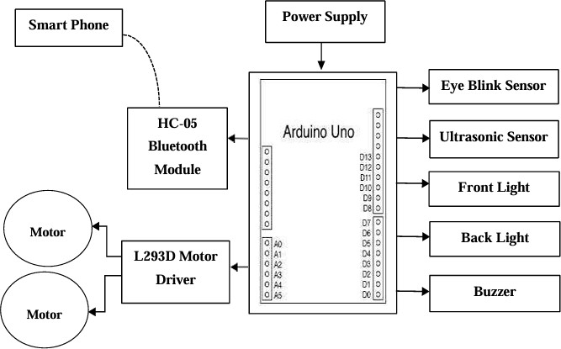

### Figure 1: Block Diagram

The Arduino microcontroller-based accident avoidance vehicle system comprises three essential components: input, processing, and output. The synergy among these components is crucial for the seamless operation of the system. The input section incorporates two ultrasonic sensors and a power supply. Data processing is handled by a microcontroller (Arduino), while the output section includes a buzzer, LED indicators, and a DC servo motor. In the input stage, the ultrasonic sensors continually gauge the distance between the vehicle and any obstacles in its vicinity, transmitting this data to the microcontroller for analysis. The Collision Avoidance System operates through two primary object detection modes: the alarm range and the automatic braking system. Equipped with obstacle detection capabilities, the system anticipates potential obstacles ahead of the vehicle and calculates the distance to these objects. Upon receiving data from the sensing device, the control module determines whether the detected object falls within the alarm range or the braking range based on pre-fed parameters and control algorithms.

# FLOW CHART

## We have designed our system flow chart based on the following algorithm.

* Initially, the ultrasonic sensor detects the presence of obstacles in the vehicle's path.

## Upon detecting an obstacle, the sensor transmits a signal to the Arduino microcontroller.

* The microcontroller receives the signal and evaluates its strength, which corresponds to the distance of the obstacle relative to the vehicle.

## If the obstacle is within the alarm position, indicating a moderate distance, the microcontroller activates the alarm to alert the driver.

* If the obstacle is closer to the vehicle, the microcontroller automatically reduces the vehicle's speed to maintain a safe distance.

## If the obstacle is dangerously close, the microcontroller triggers both the alarm and initiates the vehicle's braking mechanism, bringing it to a stop to avoid collision.

We have designed our system flow chart based on the following algorithm.

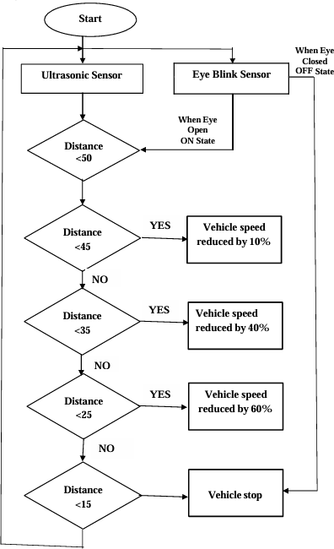

**Figure 2: Flow Chart**

# HARDWARE TOOLS REQUIREMENTS

## A. ARDUINO UNO

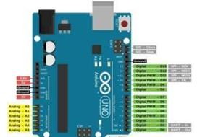

Figure 3: Arduino UNO

The Arduino Uno shown in figure 4.1 stands as an open-source microcontroller board originating from Arduino.cc, built around the Microchip ATmega328P microcontroller. This versatile board

features a range of digital and analog input/output (I/O) pins, facilitating connections to diverse expansion boards (shields) and external circuits. Boasting 14 digital I/O pins, six of which support pulse-width modulation (PWM) output, alongside six analog I/O pins, the Uno offers flexibility in interfacing with various peripherals. Programming the board is made accessible through the Arduino Integrated Development Environment (IDE), utilizing a type B USB cable for connectivity. Power options include USB cable connection or an external 9-volt battery, with a voltage acceptance range spanning from 7 to 20 volts. In its functionality and capabilities, the Arduino Uno bears resemblance to the Arduino Nano, offering a user- friendly platform for electronics projects and prototyping endeavors.

B..POWER

The Arduino Uno offers multiple power options, including USB connection or external power supply, with automatic selection between them. External power, excluding USB, can be sourced from an AC-to-DC adapter (wall-wart) or battery. Connection of an adapter involves plugging a 2.1mm center-positive plug into the board's power jack. For battery operation, leads are inserted into the Gnd and Vin pin headers of the POWER connector. The board operates within a voltage range of 6 to 20 volts. Voltage supplied below 7V may cause the 5V pin to output less than five volts, leading to potential instability. Conversely, exceeding 12V may result in overheating of the voltage regulator, risking damage to the board. The recommended voltage range is 7 to 12 volts. Key power pins include

* VIN, which serves as the input voltage when an external power source is utilized.
* 5V, providing regulated 5V output from the onboard regulator.
* 3V3, offering a 3.3-volt supply from the regulator with a maximum current draw of 50 mA.
* GND, serving as ground pins for circuit connections. C.MEMORY

The ATmega328 microcontroller boasts 32 KB of flash memory, with 0.5 KB allocated for the bootloader. Additionally, it features 2 KB of SRAM and 1 KB of EEPROM, accessible for reading and writing through the EEPROM library.

## D. INPUT OUTPUT

The Arduino Uno offers versatile functionality across its 14 digital pins, each capable of being configured as input or output using functions like pinMode(), digitalWrite(), and digitalRead(). Operating at 5 volts, each pin can handle a maximum current of 40 mA and includes an internal pull-up resistor (20-50 kOhms), which is inactive by default. Certain pins feature specialized roles:

* Serial (0/RX, 1/TX): These pins manage TTL serial data transmission and reception, connected to the corresponding pins of the ATmega8U2 USB-to-TTL Serial chip.
* External Interrupts (2, 3): Configurable to trigger interrupts on low value, rising or falling edge, or change in value, using the attachInterrupt() function.
* PWM (3, 5, 6, 9, 10, 11): Deliver 8-bit PWM output via analogWrite() function.
* SPI (10/SS, 11/MOSI, 12/MISO, 13/SCK): Support SPI communication through the SPI
* LED 13: An onboard LED linked to digital pin 13, illuminating when the pin is HIGH and off when LOW.

Furthermore, the Uno features 6 analog inputs (A0 through A5), offering 10-bit resolution (1024 values) by default, measuring from ground to 5 volts. The upper range can be adjusted using the AREF pin and analog Reference() function. Some pins offer additional specialized functionality.

E.DC MOTOR:

Motors serve as devices converting electrical energy into mechanical energy, with DC motors specifically operating on direct current (DC) electricity.

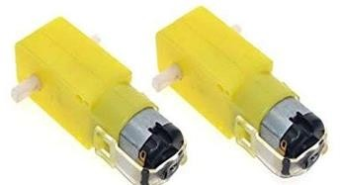

### Figure 4: DC Motor

Their functionality hinges on fundamental electromagnetism principles: a current passing through a conductor induces a magnetic field, and when placed within an external magnetic field, the conductor experiences a force proportional to both the current and the field's strength. This attraction and repulsion, reminiscent of magnetic interactions, underpin the operation of DC motors. DC motors harness this magnetic interplay to produce rotational motion. Their internal design is meticulously crafted to facilitate this process, with permanent magnet DC motors increasingly favored for their compactness, high torque, efficiency, and low power consumption. In brushed DC motors, mechanical brushes establish contact with electrical contacts on a commutator attached to an armature. This setup creates an electrical circuit between the DC power source and the armature's coil windings. As the armature rotates, the stationary brushes connect with various segments of the rotating commutator, enabling current flow and consequently generating rotational motion.

## F.EYE BLINK SENSOR

Eye Blink Sensor is a straightforward device designed to detect eye blinks using an infrared sensor. It is typically mounted on glasses, resembling regular spectacles. The infrared sensor, positioned to align with the user's eye, generates a HIGH signal when it detects a blink, indicating the closure of the eye. Additionally, the sensor is equipped with an indicator LED to notify the user of detected blinks.

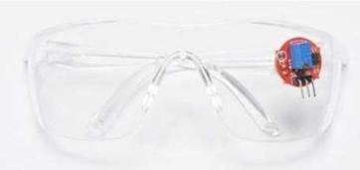

### Figure 5: Eye Blink Sensor

By pairing the sensor with a microcontroller and writing appropriate code, various metrics related to blinking behavior can be recorded and analyzed, enhancing the sensor's utility in diverse applications.

## G.ULTRASONIC SENSOR

An ultrasonic sensor functions as an electronic device to gauge the distance of a target object by emitting ultrasonic sound waves and converting the reflected sound into an electrical signal. These waves travel at speeds faster than audible sound. The sensor comprises two primary components: the transmitter, responsible for emitting sound via piezoelectric crystals, and the receiver, which captures the sound after it has traversed to and from the target.Ultrasonic

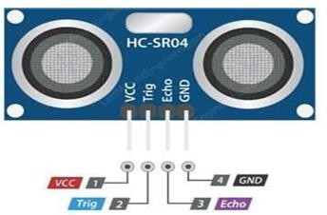sensors are widely utilized in automated factories and process plants to detect object movement and measure distances. They typically offer either a digital output, indicating the presence or absence of objects, or an analog output proportional to the distance between the sensor and the target.

## M.HC-05 BLUETOOTH MODULE

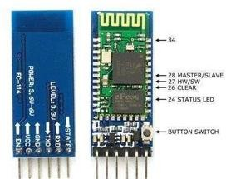

**Figure 9: HC-05 Bluetooth Module**

## H. BUZZER

### Figure 6: Ultrasonic Sensor

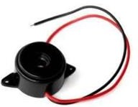

**Figure 7: Buzzer**

The HC-05 Bluetooth module is a versatile communication tool used in various consumer applications such as wireless headsets, game controllers, wireless mice, wireless keyboards, and more. It operates within a range of up to approximately 100 meters, depending on factors like atmospheric conditions, geographic location, and urban environments. This module adheres to the IEEE

802.15.1 standard protocol, enabling the establishment of wireless Personal Area Networks (PANs). It utilizes frequency-hopping spread spectrum (FHSS) radio technology to transmit data wirelessly. Communication with devices occurs via serial communication, with the module communicating with a microcontroller through a serial port (USART).

## N. LED

An audio signaling device, such as a beeper or buzzer, primarily converts electrical signals into audible sound. Typically powered by direct current (DC) voltage, these devices find applications in timers, alarm systems, and other alert mechanisms. Depending on their design, they can produce various types of sounds to suit different requirements.

## I.L293D MOTOR DRIVER

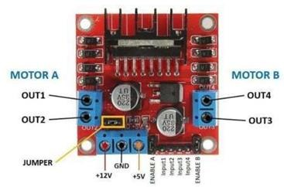

### Fig 8: L293D Motor Driver

A motor driver IC is an essential component in autonomous robots and embedded systems, controlling the movement of motors based on instructions received from a controller. The L293D and ULN2003 are two widely used motor driver ICs, particularly in simple robots and RC cars. These ICs employ an H-bridge topology, allowing them to control the direction of the motor based on input signals from the controller.

### Figure 10: LED

A light-emitting diode (LED) is a semiconductor device that emits light when an electric current flows through it. It is essentially a p- n junction diode that has been specially doped and manufactured using specific semiconductor materials. When the LED is forward biased, meaning current is applied in the forward direction, it emits light.

# Software Required

* + Arduino IDE
  + Bluetooth RC Controller

## A. Bluetooth RC controller ARDUINO IDE software



### Figure 11: Arduino IDE

Arduino is an open-source prototype platform comprising both hardware and software components. Its hardware includes a

programmable circuit board, often referred to as a microcontroller, and its software is known as the Arduino Integrated Development Environment (IDE).

## B.BLUETOOTH RC CONTROLLER

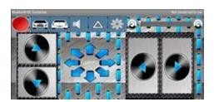

### Figure 12: Bluetooth RC Controller

Bluetooth RC Car is an education app developed by Andi,Co. The APK has been available since August 2012.

# VII RESULTS & DISCUSSION

The "Automatic Speed Control and Accident Avoidance of Vehicles using Sensors" project has undergone successful design and testing. In this system, ultrasonic sensors play a crucial role in detecting obstacles in the vehicle's vicinity. When the ultrasonic sensor registers a distance greater than 50cm, indicating an absence of obstacles, the driver maintains full control over the vehicle's speed. However, as the sensor reading falls between 50cm and 45cm, signifying the presence of a distant obstacle, the vehicle's speed is gradually reduced, providing the driver with sufficient time to react appropriately. Subsequently, if the sensor reading ranges from 45cm to 15cm, indicating a closer obstacle, the vehicle's speed is further decreased, allowing for enhanced reaction time. Finally, when the ultrasonic sensor detects a distance below 15cm, indicating imminent collision, the system automatically brings the vehicle to a complete stop. This sequence ensures proactive accident avoidance by adjusting the vehicle's speed based on the proximity of obstacles, thereby enhancing overall safety on the road.

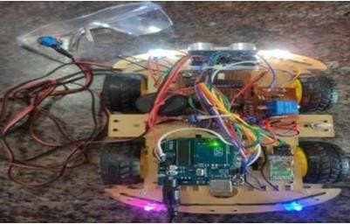

**Figure 13: Result of Automatic speed control and accident avoidance system**

# CONCLUSION

Automatic speed control and accident-avoidance systems using sensors have the potential to greatly improve driving safety by leveraging sensor technologies to detect obstacles, road conditions, and other vehicles in real-time, and automatically adjust the vehicle's speed or take preventive actions to avoid accidents. These

systems can offer several advantages, including reducing the risk of collisions, preventing speeding, improving driver awareness, and enhancing overall road safety.

REFERENCES

## Adnan M. Al-Smadi, Wasan Al-Ksasbeh, Mohammad Ababneh, Manar Al-Nsairat “Intelligent Automobile Collision Avoidance and Safety System” (IEEE, 2020).

1. Mahesh A. Rakhonde; Prof. Dr. S. A. Khoje; Prof. R. D.Komati “Vehicle Collision Detection and Avoidance with Pollution Monitoring System Using IoT” (IEEE, 2018).

## P. Ramya, R.K. Kavin, R. Rathish, M. Sathees Kumar, R. Karthi Kumar “Accident Avoidance and Prevention System” (IJESC, 2020).

1. Aditi Padayar, Dipali Jadhav, Priti Pashte, Shweta Lagade, Prof. S. K. Srivastava “Microcontroller -based Accident Prevention System Using IOT” (JETIR, FEB 2020).

## Mubashir Murshed, Md Sanaullah Chowdhury ICATIS. “IoT-based Car Accident Prevention and Detection System with Smart Brake Control” (2019).

1. Rachita Shettar, Sandeep Dabhade, Basavaraj Viraktamath, Amit Dalal, Varsha B Vannur “Design and Development of Accident Prevention and Control Systems"(IJERT, 2015).

## Abdelwahab, M., Abdel-Maguid, M., & Emary, I. Adaptive cruise control with stop-and go and traffic jam assist: A comprehensive review. IEEE Transactions on Intelligent Transportation Systems, 19(1), 1-17, (2016).

1. Radhakrishnan, S., Somanath, S., & Abhayaratne, C. A review on vehicle speed control techniques. IEEE Transactions on Intelligent Transportation Systems, 17(11), 3188-3203, (2016).